SCARA Precision Results
Lecture 2 describes forward kinematics as combining joint rotations and translations to obtain Cartesian position relative to the robot origin. The SCARA script uses the expanded sine-and-cosine equations with the actual offsets on page 15 of the coursework, including dimensions simplified in the lecture examples.
Four poses were tested using q1 and q2 (angles in radians) and q4 (shaft displacement in metres), with shaft rotation fixed. After settling, the controller measured the shaft-end tool centre point (TCP) using the same base-relative pose method as the supplied supervisor.
For Task 1.C, the CSV compares calculated and measured x, y, z in the arm base frame. error_m is their straight-line (Euclidean) distance in metres. It includes any difference between commanded and achieved joint positions.
The four poses have a mean error of 0.119 mm and a maximum of 0.120 mm. These results check the four tested poses only, not the entire workspace. The recorded results are shown below:
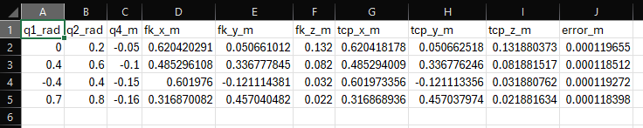

Sources: Lecture 2 - Kinematics and Inverse Kinematics (Kinematics and The Basic Kinematic Equation); Coursework 1, pp. 9 and 15-16; Formula sheet, section 7 (Rotation Matrices).

